Name: _______________________ Class: __________ Date: _______
Instructions: Write answers in the right-hand column. Score: ___________ / 45 marks
Section A— Multiple choice (10 marks)

 | The nearest star to Earth is:  A Proxima Centauri.  B Alpha Centauri.  C Southern Cross.  D the Sun. | d | 1
 | Stars cannot be seen in the day because:  A they are turned off.  B they are too dull to be seen against the intense light from the Sun.  C they do not exist in that part of the sky seen during the day.  D they are blue in colour and so cannot be seen against the blue sky. | b | 1
 | Which of the following is a dwarf planet?  A Pluto  B Earth  C Jupiter  D the Moon | A | 1
 | Which of the following has a gravitational force field around it?  A The Sun  B The Earth  C The person sitting next to you  D Everything with mass has a gravitational force field. | d | 1
 | As you move away from Earth, its gravitational force field:  A gets stronger.  B weakens.  C always stays the same.  D is zero. | b | 1
 | The diagram below shows the orientation of the Earth, Sun and Moon when a spring tide occurs.  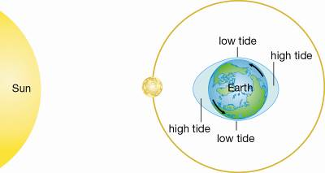  The phase of the moon during a spring tide is:  A New moon  B First quarter  C Full moon  D Last quarter | A | 1
 | The type of tide shown in the diagram below is:  A Low tide.  B Spring tide.  C Neap tide.  D Leap tide.  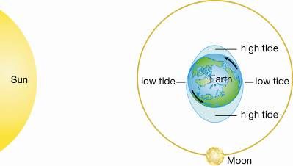 | C | 1
 | A lunar eclipse is when:  A the Moon travels around Earth in an orbit shaped like an oval.  B Earth blocks sunlight from reaching the Moon.  C the Moon blocks sunlight from reaching the Sun.  D you only see part of the Moon because of its angle to the Sun. | b | 1
 | Earth’s axis is tilted at an angle of 23.5°. Imagine it didn’t tilt. Which of the following statements would then be true?  A Earth would have the same seasons as it does now.  B Earth’s seasons would be longer than they are now.  C Earth would not have any seasons at all.  D The length of the day would change. | c | 1
 | Which of the following statements about small solar system bodies is true?  A Most asteroids are located in a belt between Mars and Jupiter.  B Meteors partly burn up as they enter Earth’s atmosphere, the rest striking the surface and leaving craters behind.  C Comets are also known as ‘shooting stars’.  D Solar winds blow comets towards Earth. | a | 1

Section B— Short answer (25 marks)

 | Contrast planets and stars by describing two differences between them. | Any two of the following:  Planets reflect sunlight whereas stars make their own light (via nuclear reactions).  Planets are much smaller than stars.  Planets orbit a star whereas stars usually don’t orbit anything. | 2
 | Construct a simple diagram to show what an ellipse is. | Any sketch of an oval would be acceptable. | 1
- 1 | a Define the term orbit.  b Identify three objects that orbit and, state what each of them orbits. | a Orbit means to revolve around another object.  b Any two of the following:  Planets orbit the Sun, comets orbit the Sun, asteroids orbit the Sun, moons orbit planets, artificial satellites orbit planets, stars can orbit each other. | 4
 | Classify the following as natural or artificial satellites.  a The Moon  b The International Space Station (ISS)  c Halley’s Comet  d Hotbird European communications satellite | a Natural  b Artificial  c Natural  d Artificial | 4
 | Explain how a satellite can keep orbiting without using its rockets or engines. | The satellite is in freefall. | 2
 | Construct two simple labelled diagrams to contrast the geocentric model of the solar system with the heliocentric model. | Two diagrams needed.  The geocentric model has the Earth in its centre with everything revolving around it.  The heliocentric model has the Sun in its centre with all planets revolving around it. | 2
 | State how long Earth takes to:  a rotate once on its own axis.  b travel once around the Sun. | a 24 hours or 1 day  b 365¼ days or 1 year | 2
 | In the diagram below are two regions labelled A and B.  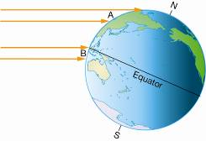  a Identify which region would have the hottest climate.  b Justify your answer. | a Region B.  b Sunlight strikes the Earth’s surface in Region B more directly and on less of an angle than in Region A. This concentrates the light and heat across a smaller area. This makes Region B hotter than Region A. | 3
 | Compare and contrast astronomy and astrology. | Both astronomy and astrology involve the study of the movement of stars, planets and the motions of the Earth in space.  Astronomers study the heavens scientifically, making observations, taking measurements and developing testable theories.  Astrologers attribute the movements of the distant objects in the sky with the power to determine people’s futures and their personalities. Astrology is not based on scientific insight. | 3
 | The Moon is about the same age as the Earth. Propose a reason why the Moon has millions of visible craters from meteorite impacts, whereas the Earth has only a few hundred. | The Earth’s atmosphere protects the surface since most meteoroids burn up during entry into the atmosphere. The Moon has no protection because it has no atmosphere. | 2

Section C— Thinking scientifically (10 marks)

 | The dwarf planets Pluto and Ceres have diameters of 2300 km and 980 km respectively. If a model of the universe is constructed in which Pluto is represented by a ball of diameter 10 mm, then the model of Ceres would have a diameter of approximately:  A 4 mm  B 23 mm  C 98 mm  D 40 mm | A | 1
 | The diagram below shows a model that was constructed to demonstrate the effect of the Earth’s tilted axis. A torch is used to represent the Sun.  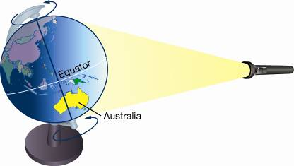  In this position, Australia is experiencing:  A night.  B day.  C winter.  D Not enough information to decide. | B | 1
 | In the model in question 2, what time of day is it in Perth, Western Australia?  A Midday  B After sunset  C Midnight  D Early morning | D | 1
 | In the model in question 2, what season is it in Australia when it is in this position?  A Autumn  B Summer  C Winter  D It is not possible to determine the season from this model. | B | 1
 | Leap years have 1 day added to them. The following key can be used to calculate if any year will or will not be a leap year.  Is the year divisible by 400? Yes? The year is a leap year.  If not, is the year divisible by 100? Yes? The year is a normal year.  If not, is the year divisible by 4? Yes? The year is a leap year.  Use this information to calculate which of the following years was a leap year.  A 1500  B 1700  C 1600  D 1800 | B | 1
 | The years below were all important years in Australia’s history. Which year was not a leap year?  A 1788: First Fleet arrives in Sydney  B 1901: Federation of Australia  C 1968: Aborigines are allowed to vote  D 2000: Sydney Olympics | B | 1
 | The Moon takes 27.3 days to rotate once on its own axis. It also takes 27.3 days to revolve once around Earth on its orbit. Because of this:  A on Earth we only ever see one side of the Moon, regardless of where it is in its orbit.  B we see a full Moon every 27.3 days.  C we only see the Moon once every 27.3 days.  D the Moon disappears from view once every 27.3 days. | a | 1
 | Mnemonics are ways of helping you remember something difficult. They are often used to remember the order of the planets from the Sun. Which of the following mnemonics correctly describes this order?  A My Vinyl Egg Makes John’s Seem Under Nourished  B Nigel’s Under Slime Juice! Michael Existed Very Majestically  C Just Sitting Under Neath, Maggie Viewed Every Magpie  D Very Many Extra Mice Niggled Some Jelly Up | a | 1
 | The distance from Earth to the Moon is 400 000 km. The distance from Sydney to Cairns is 2000 km. This means that a trip from Earth to the Moon and back is equivalent to:  A 200 trips from Sydney to Cairns and back.  B 400 trips from Sydney to Cairns and back.  C 100 trips from Sydney to Cairns and back.  D 2000 trips Sydney to Cairns and back. | a | 1
 | The distance from the Sun to Earth is 150 million kilometres or 150 000 000 km. This distance is also known as the Astronomical Unit (AU). This means that 1 AU = 150 000 000 km.  The distance from the Sun to Mars is 230 million kilometres. When Earth and Mars are closest to each other, approximately how far is it between them?  A 0.5 AU  B 150 million kilometres  C 2 AU  D 80 kilometres | a | 1

